<<20130303>> Archived distributions can be retrieved at; <http://tinyurl.com/azg3eyl>. This archive includes a html version of this list distribution and its MS/WORD version with its filename as “year-month-date.doc.” You can also access all of its attachments, if any.
Muriel Glasgow MPH
Idea Generator,
President MG Associates, Inc
Founder, STEM Clubs for Kids
Producer, The Yakkers' Corner
212-826 9697
muriella@gmail.com
www.unitednationsyak.com
http://about.me/murielglasgow
References:
(a) The Global Early Warning System (GEWS) with The Global University System (GUS): Their Use Within ECOWAS Countries; A Priority Agenda Item of the First GEWS/GUS Planning Workshop at School of International and Public Affairs (SIPA), Columbia University, and The Stevens Institute of Technology (August 2, 2012)
<http://tinyurl.com/bmo9ljj>
(b) The Global Early Warning System (GEWS) with The Global University System (GUS): Their Use Within ECOWAS Countries (October 7, 2012)
<http://tinyurl.com/bqbjh9g>
Dear Muriel:
(1) Many thanks for your msg (ATTACHMENT I below).
(2) I registered to attend this water security conference at Columbia University on March 28th, 2013.
This is because the “Water Security” is the very same topic of interest in our GEWS project along Niger, Congo, Nile, Ganges, etc., rivers (References (a) and (b) above).
Dear e-Colleagues in NYC area:
(3) I strongly suggest you to attend it.
Best, Tak

ATTACHMENT I
From: Muriel Glasgow <muriella@gmail.com>
Subject: Fwd: Water Security & the State of the Planet – the Winter EI Newsletter
Date: March 2, 2013 6:53:32 PM EST
To: Tak Utsumi <takutsumi0@gmail.com>, Dennis Ramdahin <sustainable.development@yahoo.com>
FYI
From: "Earth Institute" <ei-news@ei.columbia.edu>
Date: February 28, 2013, 12:13:43 PM EST
To: <muriella@att.net>
Subject: Water Security & the State of the Planet – the Winter EI Newsletter
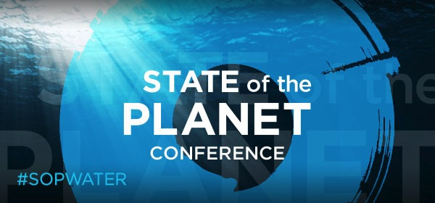
A World at Risk: Water Security
An estimated 780 million people do not have access to clean water, and almost 2.5 billion lack access to adequate sanitation, according to the United Nations. Six to eight million people die annually from the consequences of disasters and water-related diseases. Population increase, rapid urbanization and changing climate are constraining water and food systems in many places in the world.
The ability of societies to deal with these threats is coming into question, whether the issue is the provision of safe drinking water, access of industries to water, rapid depletion of groundwater by agriculture, limits to energy production and mineral extraction, or the impacts of degraded water bodies on ecosystems. What innovations and sustainable solutions can address these challenges?
The next Earth Institute State of the Planet conference, on March 28, will focus on water. Institute Director Jeffrey Sachs will join policymakers and scientific experts for a discussion at Alfred Lerner Hall, Columbia University.
Sign up for the conference, or plan to join us via the webcast and social media. For details, visit the State of the Planet conference website <http://stateoftheplanet.org>.

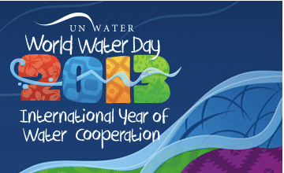
The United Nations has named 2013 the International Year on Water Cooperation, and events on World Water Day, March 22, and throughout the year will focus on the ways in which nations are coming together to solve regional water problems.
Competition for water has been tied to conflicts in China, Yemen and many other countries. But in some places, the parties have found ways to cooperate. In Valencia, Spain, farmers use an ancient water court to settle disputes. For decades now, Jordan and Israel have negotiated their water needs. The Indus Water Treaty between Pakistan and India has survived three major conflicts.
The increase in demand for water access, allocation and services worldwide offers both challenges in cross-boundary water management, and opportunities for increased cooperation. Such cooperation carries economic benefits, and can help alleviate poverty, preserve water resources and protect the environment. It can also promote sustainable development, and peace.
Learn more about the issues on the World Water Day website <http://www.unwater.org/water-cooperation-2013/home/en/>. And check out our series of interactive maps <http://blogs.ei.columbia.edu/2013/02/28/geocharts-water-challenges-around-the-world/> showing water challenges around the world.
Fieldwork at EI
Scientists from the Lamont-Doherty Earth Observatory and other Earth Institute centers travel to every continent, from the tropics to the poles, to conduct their research. Check out our summary of upcoming fieldwork <http://blogs.ei.columbia.edu/2013/02/27/upcoming-scientific-fieldwork-a-guide/>.
WHAT WE'RE DOING
The Columbia Water Center <http://water.columbia.edu/about-us/> operates education and research programs around the world, combining scientific expertise, engineering innovation and public policy to create more sustainable water systems.
Water Crisis in Gujarat
For decades farmers in North Gujarat, India, have been tapping the region’s groundwater at unsustainable rates, leading to a precipitous drop in water tables. A Columbia Water Center pilot project is addressing the problem <http://blogs.ei.columbia.edu/2013/02/19/achieving-sustainable-water-energy-and-agriculture-in-gujarat-india/>.
Make Your Water Mark
The Aquanauts student group sponsors an interactive event <http://water.columbia.edu/aquanauts/> at Columbia on April 5, 5-7 p.m., featuring food, film and conversations with people from Columbia, NGOs and the corporate sector.
EDUCATION @ EI
Certificate in sustainable water management: A new program will teach professionals the skills to conduct integrated water management and water systems analysis. Apply by May 15 <http://www.earth.columbia.edu/articles/view/3033?utm_source=iContact&utm_medium=email&utm_campaign=Earth%20Institute&utm_content=March+Newsletter%2C+WWD>; an information session will be held March 18.
M.S. in Sustainability Management: Create sustainable solutions for your organization. Apply by May 15.
<http://www.earth.columbia.edu/articles/view/2640?utm_source=iContact&utm_medium=email&utm_campaign=Earth%20Institute&utm_content=March+Newsletter%2C+WWD>.
FOLLOW EI
https://twitter.com/earthinstitute
https://www.facebook.com/earthinstitute
This message was sent to muriella@att.net from:
Earth Institute | 2910 Broadway | New York, NY 10025
Manage Your Subscription | Forward To a Friend

*******************************************************************************
Takeshi Utsumi, Ph.D., P.E., Chairman
GLObal Systems Analysis and Simulation Association in the U.S.A. (GLOSAS/USA)
Laureate of Lord Perry Award for Excellence in Distance Education
Founder and V.P. for Technology and Coordination of Global University System (GUS)
43-23 Colden Street, #9L, Flushing, NY 11355-5913, U.S.A.
Tel: 718-939-0928; Cel: 646-589-1730; Skype: utsumi
Email: takutsumi0@gmail.com, Web: http://www.friends-partners.org/GLOSAS/
U.S./IRS Employer ID: 11-2999676 <http://tinyurl.com/534gxc>
New York State Tax Exempt ID: 217837 <http://tinyurl.com/47wqbo>
Google Profiles <https://profiles.google.com/takutsumi0/about>
Facebook <http://www.facebook.com/GlobalEarlyWarningSystemsgews>
List Distribution <http://tinyurl.com/2fzx23e>
*******************************************************************************

